Chapter 3 Living systems
extra worksheet 3: Aging bones
Science understanding, Science as a human endeavour
Your body changes as you grow older. Changes to the skeleton cause the bones of older people to lose some of the materials that make them strong. The bones become less dense, as shown in Figure 3.3.1. The bones of most 70-year-olds are about one third thinner and lighter than when they were 40 years old! The bones are also weaker and more likely to break.

Sixty percent of older women and thirty percent of older men have osteoporosis, a condition in which the density of their bones is decreased more than average, making the bones even weaker. Calcium is the main element in bone and so a diet of calcium-rich dairy products (such as milk, yoghurt and cheese) helps reduce the chance of osteoporosis developing.
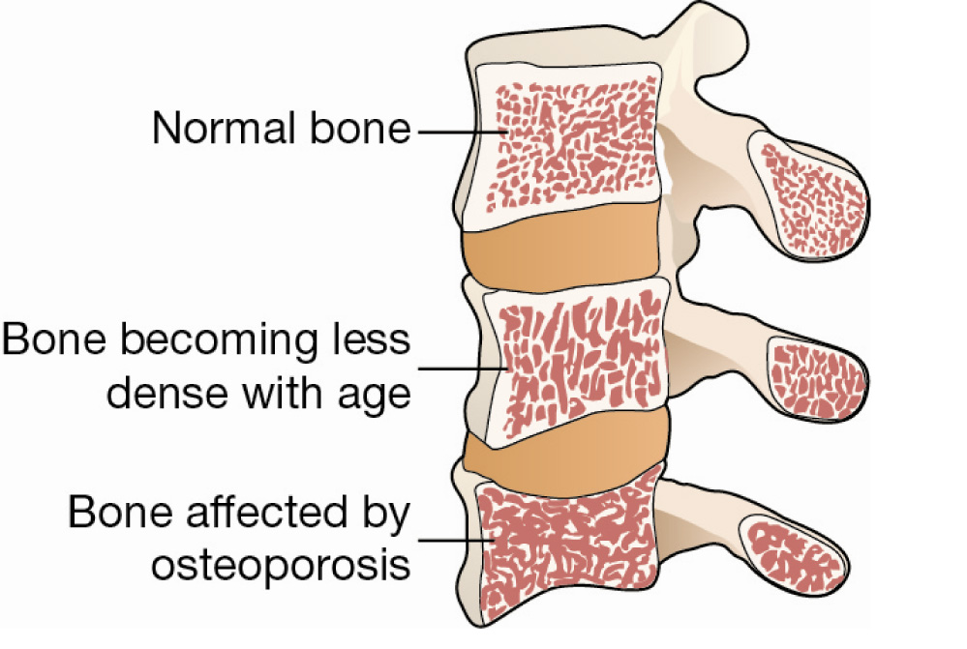
Figure 3.3.1
The changes in the density of bones as they age and are affected by osteoporosis.

Weight-bearing exercise such as jogging, fast walking, tennis, dancing and strength training are good for the health of your bones. Lifting weights or carrying your body weight causes the muscles to contract and this places stress and strain on the bones the muscle is attached to. The response of a bone to repeated strain is to increase the bone mass to become stronger.

Questions
1 Explain why older people are more likely to break their bones if they fall than a Year 8 student.

2 State how much lighter and thinner bones become between the ages of 40 and 70.

3 Explain what osteoporosis is.

4 Explain why a diet rich in calcium may help you avoid osteoporosis.

5 Explain why older people should continue to exercise regularly.

6 Astronauts arriving back from long periods aboard the International Space Station can have weakened bones, similar to those of a person with osteoporosis. Propose reasons why.

